To do

(DONE) Cover sheet
(Almost done) Executive Summary
Introduction (DONE? It seems fine already, someone should look over it)
Requirements and specification
Final Design (CAD drawings??, also includes safety section)
Project Outcome (includes acceptance test plan)
(DONE) Project Risk Assessment
Work plan/ Schedule (Can someone post the one made at the beginning of semester?? )
(DONE taken from list) Budget
(DONE taken from old report) Assessment of Context
References

Power Grip Glove – Final Report

Danny Nguyen, Ahmed Aljishi, Kishan Soni, Adam Alsadek, Mohammed Alafaisan
Senior Design II – ME4381
May 7, 2019

Executive Summary
When we started working on this project, we first had to understand who is our intended audience/users. We were required to develop a glove that helps people who are experiencing difficulties living their lives independently, due to a certain medical condition that prevents them from gripping onto objects. There are a variety of medical conditions that can cause a loss of grip strength or gripping ability in the hand. One notable example of such a condition is cerebral palsy. Cerebral palsy is the result of brain injury during fetal development, and it can affect the generation of neural signals that control the hands. Abnormal generation of these signals can cause the hands to be locked stiffly in one position. Other conditions that can affect grip strength include extreme forms of diabetic and ischemic peripheral neuropathy, in which nerves in the hand are destroyed by high glucose levels or low oxygen levels in the blood, respectively. Our goal is to create an assistive glove that can restore function to the hands of people with such medical conditions. The power grip glove has the potential to positively impact the lives of hundreds of thousands of people struggling with impaired grip strength. Developing a glove that can restore normal hand function to these patients has the potential to dramatically increase their independence, productivity, and – most importantly – quality of life.
The design process began by separating the project into three distinct functional domains: force generation and transmission, the physical, material construction of the glove, and the control system. The first area is the force generation and transmission. For the glove to amplify grip strength or to hold a hand in an open position against tension, some force must be generated somewhere, and this force must be transmitted to the fingers of the glove. In this area, we will answer questions dealing with how the force itself is generated (motors, actuators, etc.), how this force is sent to the fingers, and how the system is powered. A few examples of issues that will arise are the necessary efficiency of the system, how much power is lost through transmission, and tradeoffs between battery capacity and size/weight.
The next functional domain is the mechanical and material design of the glove itself. This area concerns the physical structure of the glove, the material used to build the glove, and the integration of the elements of force transmission into the glove. We will be concerned with the level of comfort and safety provided by the material, the total weight of the glove and its attached components, as well as the friction provided by the gloves at the site of gripping (the fingertips). The final functional domain is the control system. The control system is responsible for detecting the intent of the patient either to open his or her hand, or to grip an object. Further, the control system must contain safety measures and fail-safes to ensure that the glove does not harm the patient in any way. We mitigated the concern of applying excessive force to the fingers by limiting the stroke of our servos. The servos would guide the wires that are attached to the fingertips in order to drive the fingers to a gripping position. The servos could only move so much that when they reach their limit, it could only be a fully gripped hand, or fully opened, with a normal non damaging force acting on the fingers.
Within each functional domain, we explored several options to accomplish our objectives within our constraints. For force generation and transmission, the primary options we considered were hydraulics, pneumatics, and electromechanical force. An advantage of hydraulics and pneumatics is the ability to easily create a sustained force without the input of additional power. Once a pneumatic artificial rubber muscle is inflated, for instance, it remains inflated and provides force until the gas inside is released. The main disadvantage of pneumatics and hydraulics are the parts required; reservoirs, compressors, pumps, and tubing can be quite bulky, heavy, and costly. Electromechanical means are generally cheaper and more easily implemented. Ultimately, the force generation and transmission will be accomplished through cables attached to linear servos at one end and to the fingertips at the other. When the linear servos contract or extend, the cables pull the fingers closed into a gripping position. Cables located above the fingers are controlled by a second linear servo, and these cables pull the fingers open when not gripping.
For determining the patient’s intent to grip and to release grip, three options were considered. The first is manual activation, accomplished through a simple switch or button. The advantage of this route is that it is extremely simple to implement, not technically complex, and has low risk of failure. A major drawback is that it requires use of the non-gloved hand to operate the gloved-hand. A second option is electromyography (EMG), which measures action potentials at neuromuscular junctions. The main advantage of this method is that it is hands-free and more responsive to the user. Drawbacks lie in the technical complexity of implementation, as well as great noise inherent in EMG signals. Third option was to use a potentiometer to guide our servos. We have finally chosen a potentiometer, that way the user would control exactly how much the cables should be pulled in order to grip on something using the knob. Functionality would be explained in more detail later on the design section.
After deciding on a high-level design, the final step in the design process was to select parts, conceptualize how each part connects to form a functional power glove, apply for IRB approval, and to draft a final budget. Overall, the cost to build one power glove (with included contingency) will be approximately $580. At this point in the project timeline, we have finalized the parts and detailed design for the glove, and we are prepared to begin assembling a prototype to test.

Introduction
As the culminating project for undergraduate degrees in mechanical engineering and in electrical engineering, designing and prototyping the power grip glove will incorporate and test several domains of knowledge in these disciplines. The physical, mechanical workings of the glove rely on basic statics and dynamics as well as knowledge of materials and motor functioning. Basic load requirements for the motors must be calculated from the desired tension in the cables at the fingertips, but this is impacted by the angles at which the fingers are held and the frictional losses in transmitting force from the motors to the fingers. Once the load requirements have been calculated, knowledge of motor types is essential in choosing the best option for driving the load.
Although the control system for the glove may seem simple at first glance (turn a switch on to make the glove close), it requires a more sophisticated knowledge of control theory and signal processing. Using external signal readings as an input signal to the device makes the control non-trivial, as this signal has to map into a stable digital signal to communicate with the microcontroller. Further, a more complicated control system than an on/off switch must be used to enable multiple responses from a single continuous input. Of course, a basic understanding of microcontrollers is also required to implement the control scheme once it is designed.
Perhaps most importantly, this project reinforces our design abilities and team dynamics. While most engineering classes provide the background knowledge to be able to generate a design, the creativity and problem-solving skills required to solve such an open-ended problem can only be learned through experience. Developing the power grip glove is a fantastic exercise in pure design, team management, and risk management. The skills reinforced and developed by this project will translate directly to success in real-world engineering positions.

User Requirements
Our sponsor gave very few quantitative constraints for this project, which has afforded us much creative freedom in designing the glove. However, this project does have several primary, baseline objectives, of which all must be met for the glove to be considered a success:
- The glove allows a user to hold 5 pounds by friction alone
- The glove can open the user’s hand against tension
- The system stabilizes wrist and hand movement
- Risk of harm to the user is minimized

The following are secondary objectives and constraints that our sponsor has indicated interest in, but has not made completely mandatory for the operation of the glove:
- Electromechanical components (i.e. motors, microcontrollers, wiring, batteries, etc.) are completely wearable
- User can operate each finger independently of one another
- The system functions for at least 24 hours before it needs to be recharged or its battery needs to be replaced
- Able to hold a light grip on delicate objects as well as a strong grip on heavy, durable objects
- Motion of the thumb is fixed
- Financial cost is as low as possible

Finally, as a group we have identified several objectives that were not explicitly given by our sponsor but that we would prefer for our final product:
- System weighs less than 7.5 pounds
- Glove itself is water and heat resistant
- The glove is flexible, comfortable, and resists sweat saturation
- The glove is easy to put on, and easy to control
- The system is marketable as a standalone product

The first tier of objectives has the highest priority, followed by the second, followed by the final tier. During the implementation phase of this project, it is likely that we will encounter obstacles regarding part availability, technical complexity, and unforeseen design errors. If and when we encounter these difficulties, lower-tier objectives may need to be sacrificed to satisfy the primary objectives for the glove.

Engineering Specifications
1. Glove
1.1 Uriel Universal Size Wrist/Thumb Splint (Part 24-9029)
1.2 The wrist is held in a functional position at an angle of 35°
1.3 Total weight: 3 pounds
1.4 Material: Neoprene
1.5 Cost: $35.00
1.6 Additional elastic fabric: 85/15% polyester-rubber. Costs $7.99 per 2.75 square feet
2. Cables
2.1 McMaster-Carr push/pull control cable set with mounts and a clevis/pin connection (Part 3125K22)
2.2 Diameter: 0.04”
2.3 Tensile strength: 70,000 psi
2.4 Cost: approximately $40.00
3. Motors
3.1 Two ServoCity140mm Stroke 44lb Thrust Light Duty Linear Servos (Part L16-R-140-150-6)
3.2 Rated voltage: 4.5 to 7.5 V.
3.3 Drain current: 650 mA at stall.
3.4 Dynamic thrust: 200 N (approximately 44 pounds)
3.5 Stroke length:140 mm.
3.6 Maximum speed: 8 mm per second
3.7 Servo motors, controlled through a PWM signal with an amplitude rated between 3
and 5 V
3.8 Weight: 3.50 oz
3.9 Cost: $69.00 each
4. Battery
4.1 Rayovac 7.5 V High Capacity NiMH Battery (Part LMR7144MH)
4.2 Voltage: 7.5 V
4.3 Capacity: 2600 mAh
4.4 Rechargeable
4.5 Cost: $24.99
5. Microcontroller Board
5.1 Arduino Uno Rev3 (Part A000066)
5.2 Microcontroller: ATmega328P
5.2.1 Clock speed: 16 MHz
5.2.2 Memory: 32 kB Flash, 2 kB SRAM, 1kB EEPROM
5.3 Operating voltage: 5 V
5.4 Recommended input voltage: 7 to 12 V
5.5 Pins: 14 digital (6 with PWM output) I/O pins, 6 analog input pins
5.5.1 DC current per I/O pin: 20 mA
5.6 Weight: 25 g
5.7 Cost: $22.00

Design
In this section, we describe the parts we will use to give functionality to the device and how the parts will assemble to create the final product. We also discuss rationales for choosing each part as well as the theoretical basis behind each subsystem of the device.
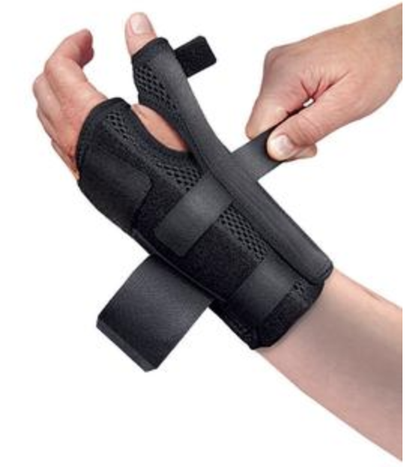
The base of the glove is the third-party wrist and thumb splint from Uriel, which functions to immobilize the wrist and thumb. Without any modifications, the thumb would be immobilized by the splint, but would not be in an optimal position for gripping. The splint contains an aluminum rod that runs the length of the wrist through the thumb restraint, and this rod can be bent to keep the thumb in an optimal gripping position. The splint itself is made of Neoprene, which is light, breathable, and water resistant. The splint has Velcro straps around the wrist that allow for individual fitting. The glove base meets one of our primary objectives by immobilizing the wrist, and it meets several secondary objectives by being light (approximately 3 pounds) and comfortable. The decision to purchase a third-party splint as the base of the glove instead of building our own was largely motivated by time and complexity constraints.

Figure SEQ Figure \* ARABIC 1. Uriel Universal Size Wrist/Thumb Splint
The splint serves as an attachment point for two sets of components: finger guides and cables. The finger guides are responsible for holding the four fingers and for routing cables from the wrist, across the palm, and to the fingertips. The finger guides will consist of several bands of elastic fabric that fit around each finger, connected by three elastic strips that run down the length of each finger, one on top of the finger and two below. The strips will be double-layered, and between the two strips will be the metal cables.
Each finger is surrounded by three cables: two below and one above. All cables run the length of each finger, then meet at two attachment points (one above and one below) on the wrist splint near the forearm. There are two main options we have finalized on for the cables. The first is a standard push/pull control cable from McMaster-Carr. The second option is to create a custom Bowden cable from Teflon tube and either standard steel wire or fishing line. The Teflon tube, functioning as the outer sheath would be purchased from Thomas Scientific and would cost approximately $4.00. The fishing line is purchased at a standard sporting goods store and is rated at 50 pounds, costing $7.00. The steel wire could also be purchased from McMaster-Carr for approximately $5.00, varying slightly based on wire diameters.
The push/pull control cable system utilizes Bowden cables, which preserve linear transmission of force despite any turns or twists of the cable. The benefit of the push/pull cable is that is a complete item that would hopefully be plug and play for the assembly of the glove. The con is that there may be higher friction losses through this type of cable. The benefit of the custom-made cable is that it is customizable and cheap. The inner wire could be altered of material or double-winded to increase the load capacity. There are also a variety of diameters for steel wire and Teflon tube. The disadvantage is that it may not look as visually appealing and it could complicate the production of multiple power gloves.

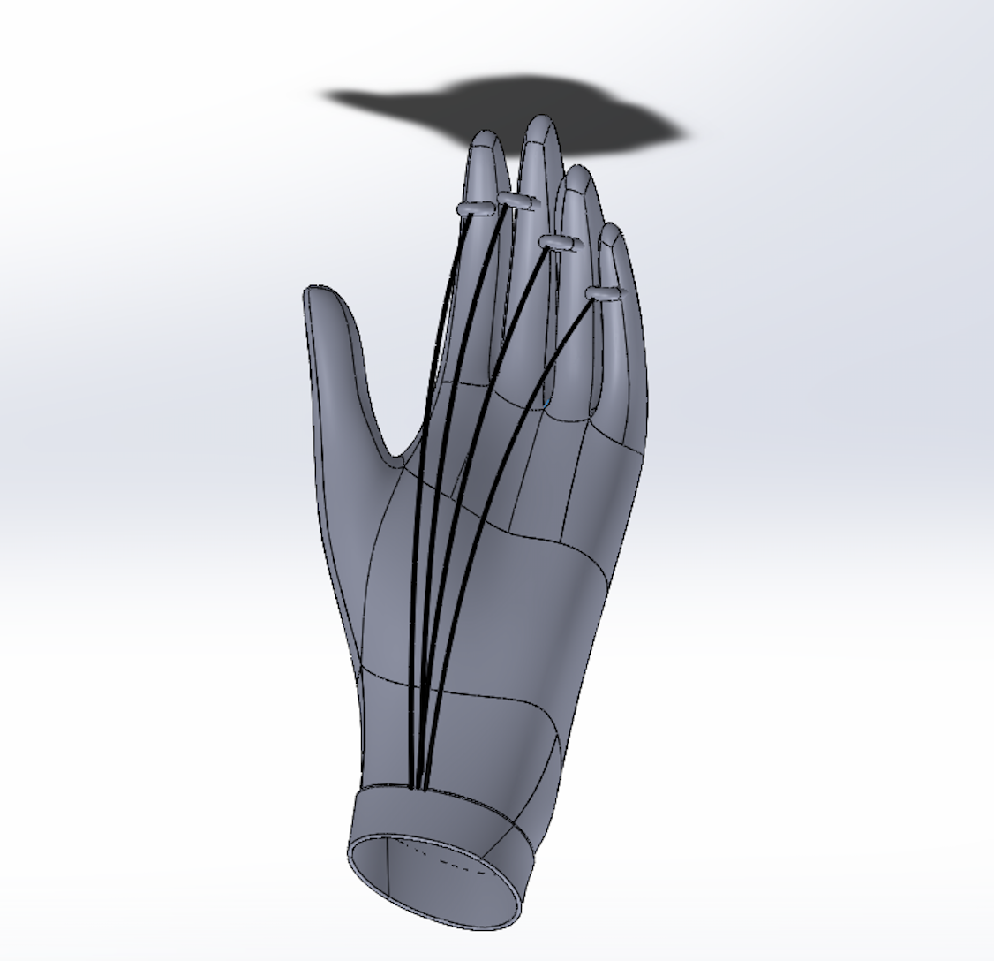
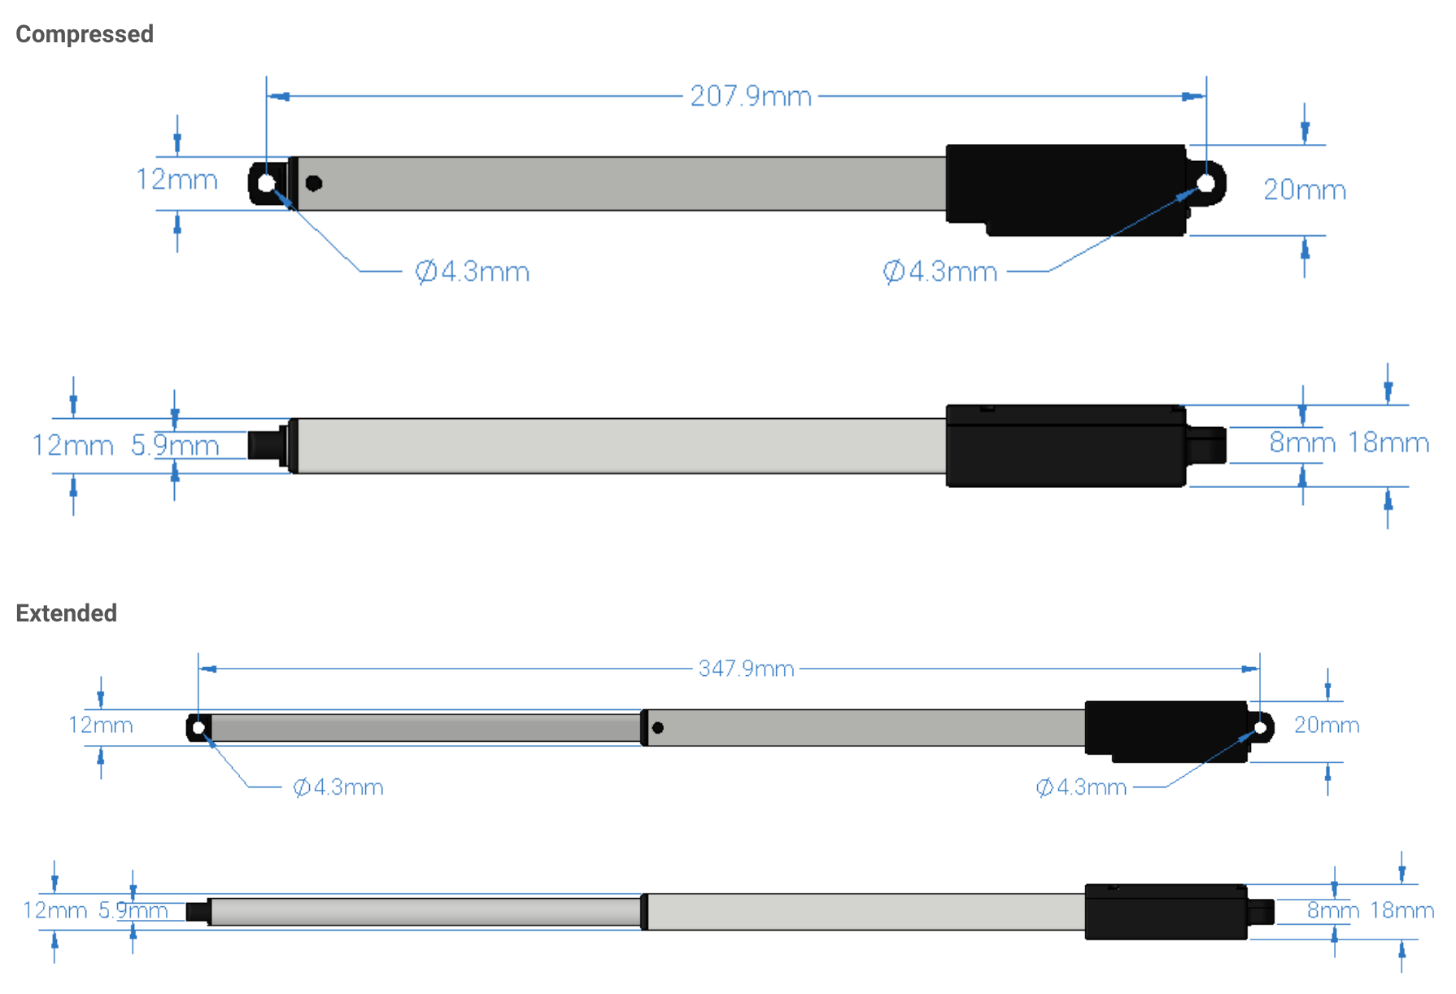
After doing much research on motors, we were debating whether to use rotors or linear actuators. Rotors would be connected to a pulley, and the pulley would drive the cables attached to the glove. We discovered that rotors tend to be heavy and they take so much unnecessary space. Also, it would be difficult to control them. With more research done regarding motors, we found that linear servos work best for our project. Linear servos could come in many different sizes with many options regarding the force they generate. Linear servos are also easy to control and light. For force generation, we have chosen two 140mm Stroke 44lbs Thrust Light Duty Linear Servos from ServoCity. We would be using two different linear servos. One of which would be for gripping, and the other for releasing. When a servo retracts, the cable attached to the end of the servo pulls the user’s fingers open or closed.

Figure SEQ Figure \* ARABIC 2. CAD model for the cable system. The glove includes two sets of steel wires that run below (2 wires) and above (1 wire). Each set of wires joins at the wrist, and is connected to the Bowden cable system

Figure SEQ Figure \* ARABIC 3. Dimensions of linear servo, both extended and compressed

Safety
When engineering a new product, safety should be the utmost priority for the engineer. Even if the product was working brilliantly, if there was a chance where the design would fail and cause problems, considerations must be made. For our design, a power grip glove, there are a lot of things to consider regarding safety. Our product consists of both electrical and mechanical components that are subjected to the possibility of failing.
One of the first objectives we agreed on when designing the product is that it should be water resistant. And we made sure that we insulate every electrical component to prevent any possible electrical shocks. Another thing we took into consideration is the amount of force that the grip could generate. We do not want the glove to produce excessive force that would be harmful for the user. For example, you do not want the user to be gripping on a doorknob so tightly that it would cause them any injuries. To avoid a problem like that from occurring, we chose a light duty linear servo that produces a small amount of force, capable of holding most objects. Moreover, the users would have the control on how much the glove should grip. The glove grip is controlled by a potentiometer that is scaled to allow user to open and grip by a maximum displacement of 2.5 inches. This will prevent users from over-gripping or closing there hands too far.
The users would be wearing the glove for a long period of time, so we made sure on choosing the right material to prevent the hands from overheating and sweating. Also, there are a lot of materials that are harmful for the skin when in contact, so that is another thing we took into consideration.
Because the glove is meant to be used on a human, the project must first be approved by the Institutional Review Board (IRB). The process requires human subject research training through CITI/NIH for each person involved in the project, as well as an application that will be reviewed by the IRB. We have completed the CITI/NIH training at this point, and we are currently in the process of completing the application for IRB approval.

Risk Assessment and Risk Management Plan
There was a risk of delay in receiving parts because, by the start of this semester, the linear servos listed in the budget plan was no longer up for sell. Due to this, we had to determine a replacement for the item. We were able to find a replacement, however, it turned out to be incompatible with our design and we had to return it and find another replacement. As a contingency plan, we started working on the linear servo code and construction of the glove while waiting for the servos to arrive.
Another source of risk is excessive technical complexity. For the design plan from the previous semester, greatest risk for the glove to function was excessive technical complexity with the EMG electrodes and pressure sensor control scheme. Without having measured the sensors’ sensitivities and resolutions, we cannot be completely certain that they will be sufficient for this application. Our contingency plan in this case is to scale down the complexity of the control system without sacrificing our primary objectives. The EMG electrodes and pressure sensor will both be replaced by a potentiometer. With a potentiometer, the user can rotate the dial until the glove grip is just right. When the potentiometer is rotated to zero, the hand is fully open and when it is at maximum, the hand is fully closed. To prevent user from opening or closing their hands too far, the linear servo is set to extend and retract by only 2.5 inches. There is much less risk of this control setup failing, and it still accomplishes our primary objectives. However, it does eliminate some of our secondary objectives (ease of use for the patient) and safety mechanisms, which is not ideal.
Further, we have built in a four-week buffer period into our schedule to allow for unforeseen obstacles and unexpected wait times. Our plan is to minimize risk of not completing the device on time and to have complete all assembly and initial testing of the device by the end of the semester.
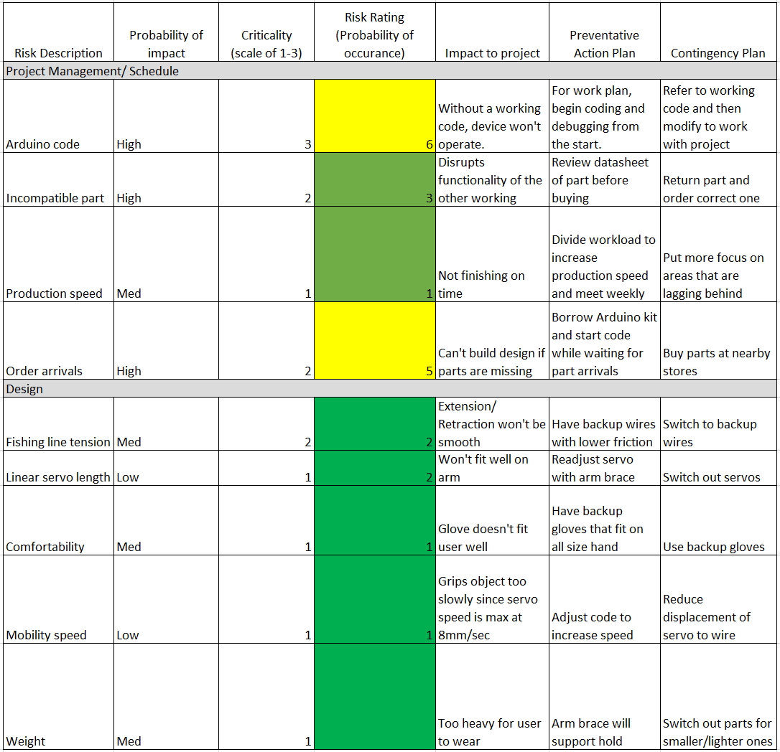
Figure xx. Risk Assessment

Schedule
The following Gantt chart displays our intended schedule for the following semester. Three of our group members will not be continuing into the second semester of Senior Design, so the remaining work is split among the three remaining members of the team. This proposed work plan is provisional, of course, as we cannot foresee the difficulties we will encounter. We have placed ourselves on a tight schedule to keep ourselves accountable, but we have also incorporated nearly 4 weeks of buffer time at the end of the semester. The buffer time is meant to minimize risk. If we need to redesign an element of the project and reorder parts, for example, the buffer will allow us to still comfortably meet our final deadline.

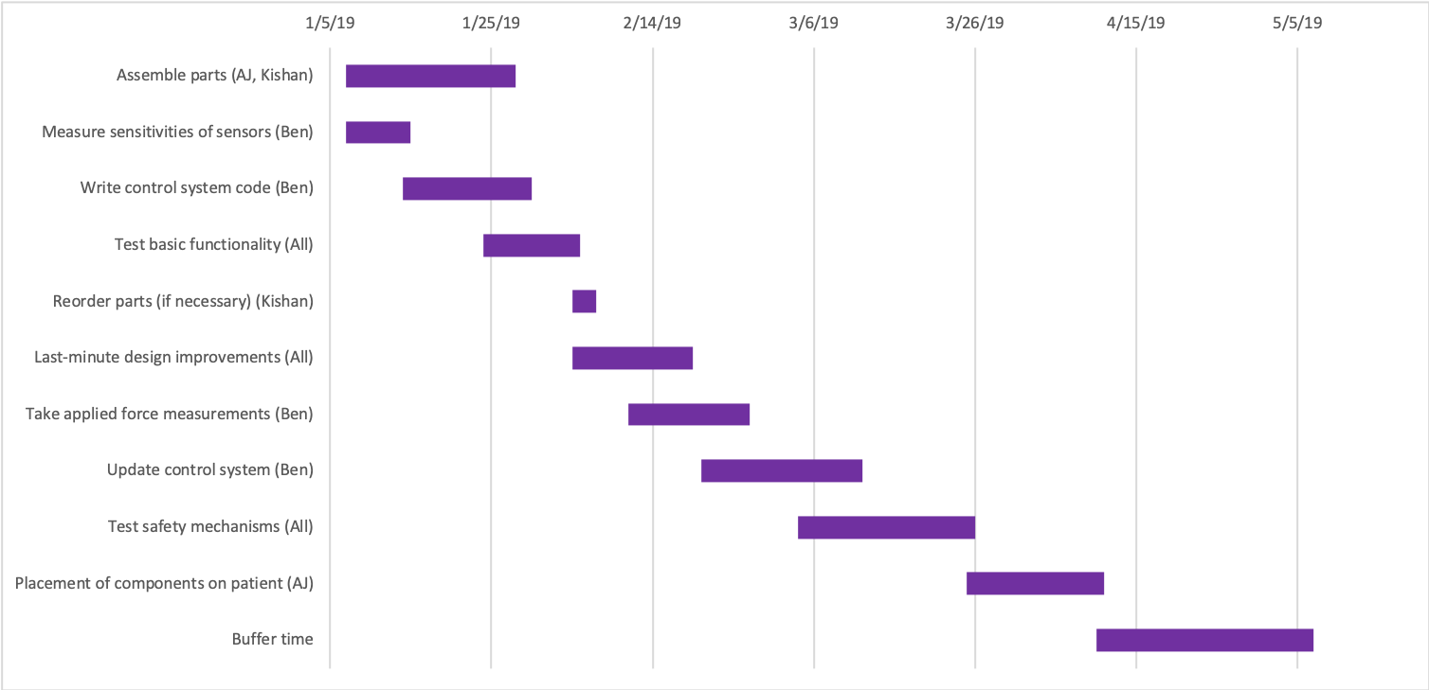
Figure 12. Work plan and schedule for the following semester

Budget

Item | Cost | Quantity | Source
Footjoy Golf Glove | $14.99 | 1 | Amazon
Uriel universal size wrist/thumb splint | $35.00 | 1 | Amazon
Sewing Kit | $5.79 | 1 | Michaels
Leather Trim | $12.49 | 1 | Michaels
L16 DC Linear Servo Motor 140mm, 150:1, 45lbs Max Force, RC and Arduino Compatible | $69.99 | 2 | Amazon
McMaster-Carr steel wire | $5.77 | 1 (22 ft.) | McMaster-Carr
Arduino Uno | $22.00 | 1 | Fry’s Electronics
MyoWare muscle sensor | $37.95 | 1 | 3B Scientific
Sparkfun biomedical sensor pads | $7.95 | 1 (10 pads) | Sparkfun
DigiKey FlexiForce pressure sensor | $24.99 | 1 | DigiKey
Rayovac 7.5V High Capacity NiMH battery | $50.99 | 1 | Rayovac
Item Returns: RoboGeek Linear Servo | $18.00 | 1 | FedEx
Total | $376.90 | - | -

Assessment of Context
If this product were mass produced by a large company, it could have huge global impacts. In areas without access to state-of-the-art healthcare or with people who cannot afford more expensive solutions, the power glove could be an immense benefit. It could also be used for industrial purposes. Workers doing tedious work that involves gripping could use this glove to decrease the wear and strain on their tendons, increasing the quality of their work life. Stronger power gloves could even be created and used by rescue personnel to clear debris or move other objects that normally would be difficult to move. It’s even possible that power gloves could be adopted by and adapted to militaries across the world. With heavy duty improvements, the power glove could be used as a weapon with immense crushing force. Although this is unlikely, the development of the ideal power glove could still have large implications for the world.
For the company, economic benefits could be immense. Due to the simple design and the inexpensive materials we chose to use, the glove would be far below the price point of other prosthetic devices. This would mean our power glove would be the main go-to solution for people with medical conditions who need to restore grip strength. From the progress made on this glove, it would also be easy to create similar prosthetic parts for other parts of the body such as the feet and arms. Assuming these are also made in a similar minimalist, low-cost fashion, the company could be the main supplier of affordable consumer prosthetics. This could potentially make the company one of the most valuable in the world. With the amount of research progress made, the company could also create luxury models of the glove with higher quality materials and sensors for a wealthier consumer market and could use these profits to offset and reduce costs even further for the mass version of the glove.
The environmental considerations for this project are minimal. None of the materials used in creating the glove are particularly toxic to the environment, and the batteries we plan to use can be recycled, but that is mainly up to the consumer who buys it. Since we are keeping materials to a minimum in the glove, less waste is involved in glove production. This makes the glove environmentally friendly.
The impact to society will also be large if the glove becomes a large-scale product. As stressed before, the glove will improve the lives of many people. In just the US, an estimated 500,000 people live with cerebral palsy, with almost 10,000 new cases each year. These gloves would help them perform useful physical tasks that could mean the difference between employment and unemployment. Development of different power prosthetics could make this improvement even more dramatic. However, this could also raise certain ethical questions. Some people might argue that this type of technology can become dangerous if not regulated properly. As a popular theme in Sci-Fi movies, exoskeletons are seen by some members of the public as weapons. However, heavy FDA regulation on prosthetics makes this problem not likely, at least not on a large scale.
If adapted on a large scale, the power glove could have many positive effects on the world. Not only would it immensely help hundreds of thousands of people, but it would set the technology in motion to develop versions of the power glove for other parts of the body. Eventually a person might be able to be completely rehabilitated. From there, the technology could go even further by finding uses in industry and the military, making dangerous tasks much safer than before.

